Business Requirement Document

Procurement Activity Management System

Version Number: 1

|  |  |  |  |  |  |
| --- | --- | --- | --- | --- | --- |
| **Document Revision Control Table** | | | | | |
| **Version No.** | **Date Revised** | **Change Description** | **A/M/D (Add/Modify/ Deleted)** | **Prepared By** | **Approved By** |
| 1 | 21/02/2024 |  | A | Luke Wright | John Panicker |
|  |  |  |  |  |  |
|  |  |  |  |  |  |
|  |  |  |  |  |  |

**Table of Contents**

1. Project Objectives 4
2. Background 4
3. Scope

3.1 In Scope 4

3.2 Out of Scope 4

1. Functional Requirements

4.1 Business Requirements 5

4.2 Business Process Flows 5

4.3 Use Case Diagram 6

1. Non-functional Requirements

5.1 Performance Requirements 6

5.2 Usability Requirements 7

5.3 Security Requirements 7

5.4 Training Requirements 7

1. Reporting and quality assurance 7
2. Delivery Schedule 7
3. Constraints 7
4. Assumptions 7
5. Risks 8

**1. Project Objectives**

* Deliver a procurement activity management system that manages the procurement of goods.
* Provide one stop solution for procurement activity from purchase request to payment.
* Reduce time taken for creating several forms and documents.
* Develop user friendly system.
* Synchronization of work between different teams.

1. **Background**

Procurement activity management system will reduce development efforts across the enterprise by eliminating manually creating forms and documents in deployed. ProcAct team uncovered seriously high levels of synchronization problems between teams and increased rework .

1. **Scope**

The project has been approved by the executive management that the project manager will handle planning and implementation of the tool. A team will help the project manager in achieving the goals of the project. With the resources provided by the company the team is expected to produce the desired result.

**3.1 In Scope**

The following areas are in scope for this project:

* Development of procurement activity management system.
* Creation of inbuilt forms which can be modified accordingly.
* All the vendor information must be fed into the system.
  1. **Out of Scope**

The following areas are out of scope for this project:

* Different home pages for different teams

1. **Functional Requirements**
   1. **Business Requirements**

|  |  |  |  |
| --- | --- | --- | --- |
| **S. No.** | **Business Requirement ID** | **Requirement Description** | **Priority** |
| **1** | **BR_1** | **Purchase Request** | **High** |
| **2** | **BR_2** | **Request for quote** | **High** |
| **3** | **BR_3** | **Purchase Order** | **High** |
| **4** | **BR_4** | **Quotation** | **High** |
| **5** | **BR_5** | **Defects in goods** |  |
| **6** | **BR_6** | **Invoice** | **High** |
| **7** | **BR_7** | **Payment** | **High** |
| **8** | **BR_8** | **Goods Receipt Note** | **High** |

* 1. **Business Process Flows**

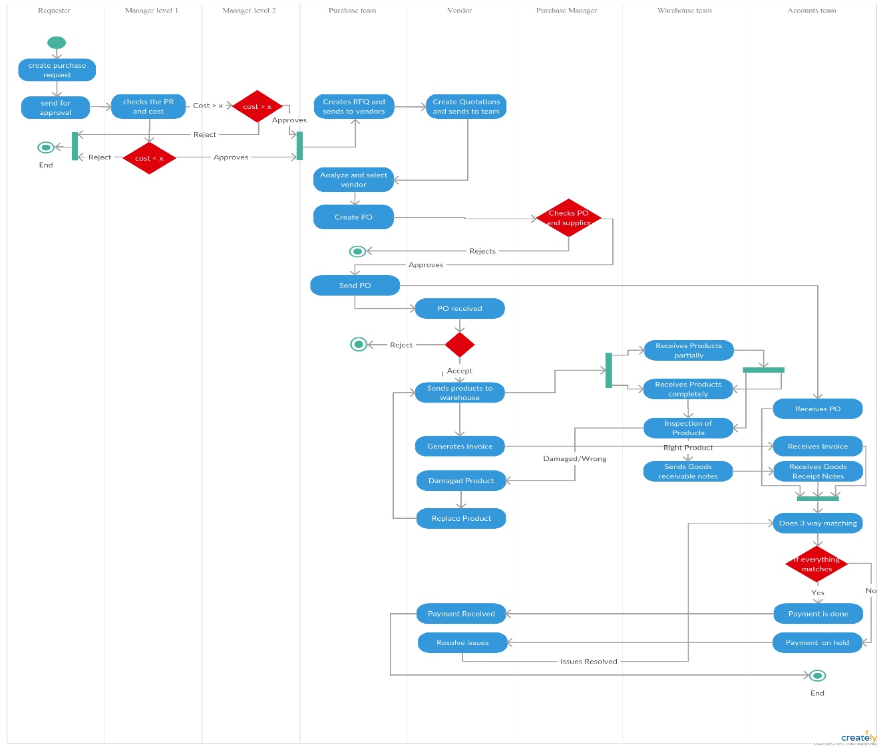

**4.3 Use Case Diagram**

1. **Non-functional Requirements** 
   1. **Performance Requirements**

* Ensure reduced time taken for page loading.
* Ensure reduced memory usage during the database processes.
  1. **Usability Requirements**
* Preparation of a manual for application usage.
  1. **Security Requirements**
* Ensure usage of secured packages in application.

1. **Reporting and quality assurance**

* **Reviews and audits**: Technical reviews should be performed by project manager to uncover problems and ensuring that quality guidelines are being followed by the team.
* **Testing**: The test plan has to be created and executed to ensure that the application is free of errors.
* **Security**: Ensure that the application uses appropriate processes and technologies.

1. **Delivery Schedule**

|  |  |  |
| --- | --- | --- |
| **Delivery Name** | **Functionalities Delivered** | **Tentative Dates** |
| Procurement activity management system | Login functionality and inbuilt forms | 21/03/2024 |
|  |  |  |
|  |  |  |

1. **Constraints**

* Unavailability of a separate testing team.
* Initial version of the application must be ready within a month.
* Only small percentage of funding for project available in current financial year.
* Team skilled with technologies and tools used.

1. **Assumptions**

* No Dedicated testing team is required.
* Enough human resources are available for the successful development of the project.

1. **Risks**

|  |  |  |  |
| --- | --- | --- | --- |
| **Type of Risk** | **Risk Description** | **Affects** | **Severity** |
| **Organizational Risk** | **Stick to the budget and track the project’s expenses to be on top of potential issues in budget** | **Resource availability for successful completion of project** | **High** |
| **External Risk** | **User friendly application** | **The client using the application** | **High** |
| **Project Management Risk** | **Dependencies on other teams** | **Efficient development and deployment of the tool** | **Medium** |
| **Technical Risk** | **Availability of skilled people to handle different technolgies** | **The development of the application** | **High** |